3.3.1 What is the difference between an Arduino and a raspberry Pi. (2)

3.3.1 An Arduino is a microcontroller and a Raspberry Pi is a microprocessor. (2)

3.3.2 List the three main types of pins on an Arduino board. (3)

3.3.2 Pins on an Arduino Uno board (3)

1. 14 Digital pins
2. 6 Analogue pins
3. Power Pins

3.3.4 What are the four key aspects of computational thinking? (4)

3.3.4 Key attributes of computational thinking.

* 1. Decomposition
  2. Pattern recognition
  3. Abstraction
  4. Algorithms

3.3.5 Arduino has two default functions i.e void setup() and void loop(). Explain purpose of each of them. (4)

3.3.6 void setup(){}- The commands put inside the curly brackets will be executed once. For example the pins used in the program can be declared in here and whereas the code in the void loop() will be executed continuously repeated constantly. (4)

3.3.7 Explain the use of inbuilt function pinMode() with examples. (4)

3.3.7 pinMode() defines how the pins of the Arduino are to work either as INPUT or OUTPUT mode.

Syntax

pinMode(pin, Mode)

Example

pinMode(11, OUTPUT) (4)

3.3.8 What’s the difference between digitalWrite() and analogWrite() in Arduino?

3.3.8 digitalWrite() sets a digital pin to either HIGH or LOW, while analogWrite() sets the voltage of a Pulse Width Modulation pin. (4)

3.3.9 Explain in brief how you can upload code to an Arduino board. (2)

3.3.9 To upload code to an Arduino board, you must connect the device to your computer using a USB cable and then you can use the Arduino IDE to upload your code to the board. (2)

3.3.10 Consider the code below and answer the question which follows.

void setup() {

  // put your setup code here, to run once:

  Serial.begin(9600);

}

void loop() {

 Serial.println("Arduino count down for loop");

   for (int i=10; i>=1; i--) {

      Serial.print("i is : ");

      Serial.println(i);

   }

delay(500);

}

After compiling the code and uploading it to the Arduino board, the output continuously display in a looping mode. Rewrite the code to stop printing when the loop reaches its limit. (2)

3.3.10

void setup() {

  // put your setup code here, to run once:

  Serial.begin(9600);

}

void loop() {

 Serial.println("Arduino count down for loop");

   for (int i=10; i>=1; i--) {

      Serial.print("i is : ");

      Serial.println(i);

   }

delay(500);

while ( Serial.available()==0){}

}

3.3.11 Write a script in using Pictoblox to display the decimal equivalent of a binary number entered through the keyboard. (5)

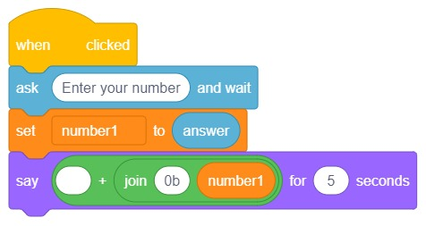3.3.11 Displaying decimal equivalent of a Binary number. (Binary to decimal convertor.

(5)